CS 305 Module Two Coding Assignment

Instructions
Replace the bracketed text with the relevant information in your own words. If you choose to include images or supporting materials, make certain to insert them in all the relevant locations in the document.

Run Dependency Check

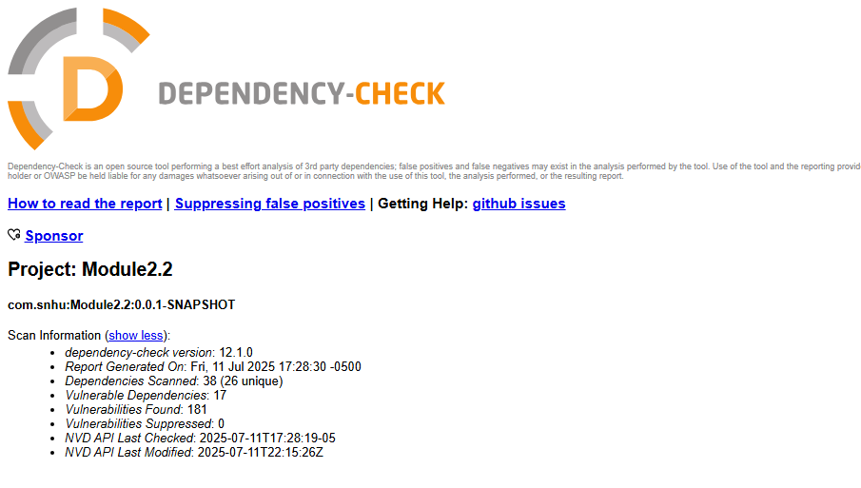

Document Results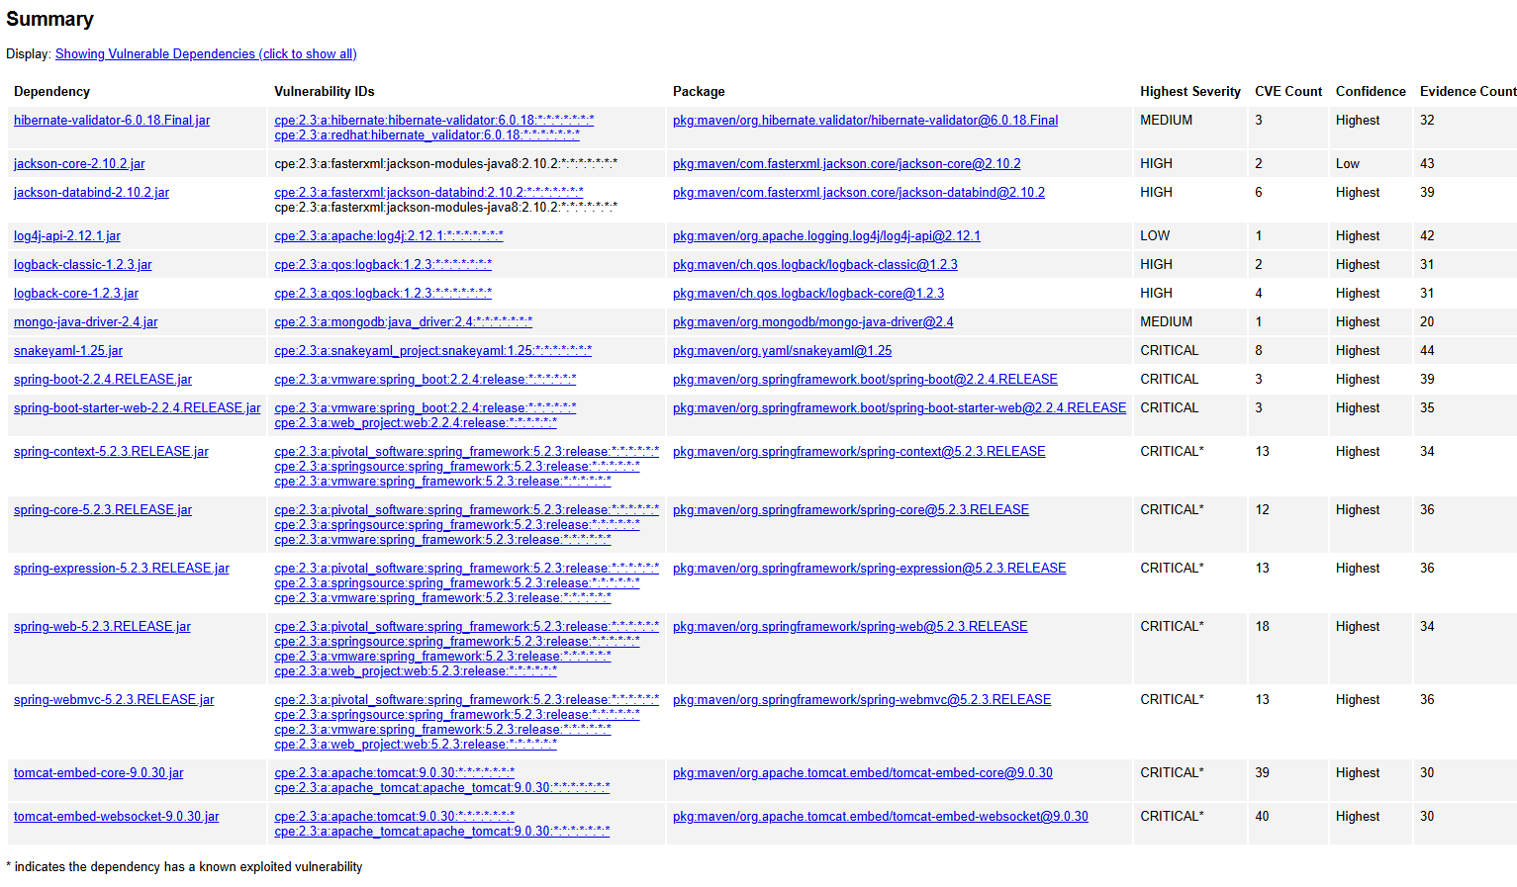

Analyze Results

- Dependency checks may occasionally result in false positives, which should be excluded to prioritize significant security risks and address those areas promptly. No false positives were identified, although several vulnerability dependencies appear in the expanded list. The library was tested, and no vulnerabilities were detected. These dependencies were not included in this report; however, each was reviewed individually to confirm the absence of vulnerabilities.

- hibernate-validator-6.0.18.Final.jar
Description: Hibernate's Bean Validation (JSR-380) reference implementation.

Solution: Upgrade to a newer version that disables EL interpolation by default and patches known CVEs:
- hibernate-validator:6.2.0.Final — safe for Spring Boot 2.7+

- Or go further with hibernate-validator:9.0.0.Final if you're on Spring Boot 3.x and Java 17+

- jackson-core-2.10.2.jar
Description: Core Jackson processing abstractions (aka Streaming API), implementation for JSON
Solution: Upgrade version of Jackson Core.

- jackson-databind-2.10.2.jar

Description: General data-binding functionality for Jackson: works on core streaming API.

Solution: Upgrade version of Jackson Core.

- log4j-api-2.12.1.jar
Description: The Apache Log4j API
Solution: If using Java 7 upgrade to at least log4j-api:2.12.3 or if using Java 8 or later upgrade to 2.17.1 or newer for broader coverage

- logback-classic-1.2.3.jar
Description: logback-classic module
Solution: Upgrade to a secure version of logback. logback-classic:1.4.7 is the latest version which is available on Maven Central.

- logback-core-1.2.3.jar
Description: logback-core module
Solution: Upgrade patched version that can address all known CVEs:
- logback-core:1.2.13 — released specifically to backport security fixes for legacy user
- Or logback-core:1.4.7 for broader improvements (if your SLF4J version supports it)
- mongo-java-driver-2.4.jar
Solution: Upgrade MongoDB Java driver to latest stable release: mongo-java-driver:5.5.1
- snakeyaml-1.25.jar
Description: YAML 1.1 parser and emitter for Java
Solution: Upgrade to a secure version that moderates all known CVEs:
- snakeyaml:2.2 — fully patched and compatible with Spring Boot 3.1.3+

- If you're on Spring Boot 2.x, use snakeyaml:1.33 as a transitional fix (still has minor issues but safer than 1.25)

- spring-boot-2.2.4.RELEASE.jar
Description: Spring Boot
Solution: Upgrade to a newer Spring Boot version that patches these CVEs:
- spring-boot:2.7.18 — latest stable release for Spring Boot 2.x

- Or go further with spring-boot:3.3.0 if you're ready to migrate to Spring Framework 6 and Java 17+
- spring-boot-starter-web-2.2.4.RELEASE.jar
Description: Starter for building web, including RESTful, applications using Spring
MVC. Uses Tomcat as the default embedded container.
Solution: Upgrade to a newer Spring Boot version that patches these CVEs:
- spring-boot:2.7.18 — latest stable release for Spring Boot 2.x

- Or go further with spring-boot:3.3.0 if you're ready to migrate to Spring Framework 6 and Java 17+

- spring-context-5.2.3.RELEASE.jar
Description: Spring Context
Solution: Upgrade to a newer Spring Framework version that patches these CVEs:
- spring-context:5.3.38 — latest stable release for Spring Framework 5.x

- Or go further with spring-context:6.1.6 if you're ready to migrate to Java 17+ and Jakarta EE

- spring-core-5.2.3.RELEASE.jar
Description: Spring Core
Solution: Upgrade to a patched version of Spring Core:
- spring-core:5.3.38 — latest stable release for Spring Framework 5.x

- Or go further with spring-core:6.1.6 if you're ready to migrate to Java 17+ and Jakarta EE

- spring-expression-5.2.3.RELEASE.jar

Description: Spring Expression Language (SpEL)

Solution: Upgrade to a patched version of Spring Expression:

- spring-expression:5.3.38 — latest stable release for Spring Framework 5.x

- Or go further with spring-expression:6.1.6 if you're ready to migrate to Java 17+ and Jakarta EE

- spring-web-5.2.3.RELEASE.jar
Description: Spring Web
Solution: Upgrade to a patched version of Spring Web:
- spring-web:5.3.38 — latest stable release for Spring Framework 5.x

- Or go further with pring-web:6.1.6 if you're ready to migrate to Java 17+ and Jakarta EE

- spring-webmvc-5.2.3.RELEASE.jar
Description: Spring Web MVC
Solution: Upgrade to a patched version of Spring Web MVC:
- spring-webmvc:5.3.38 — latest stable release for Spring Framework 5.x

- Or go further with spring-webmvc:6.1.6 if you're ready to migrate to Java 17+ and Jakarta EE

- tomcat-embed-core-9.0.30.jar
Description: Core Tomcat implementation
Solution: Upgrade to a patched version of Tomcat Embed Core:
- tomcat-embed-core:9.0.81 — latest stable release that patches CVE-2023-44487

- Compatible with Spring Boot 2.7.x and 3.x (Java 17+ required for 3.x)

- tomcat-embed-websocket-9.0.30.jar
Description: Core Tomcat implementation
Solution: Upgrade to a patched version of Tomcat Embed WebSocket:
- tomcat-embed-websocket:9.0.81 — latest stable release that patches CVE-2023-44487 and other known issues

- Compatible with Spring Boot 2.7.x and 3.x (Java 17+ required for 3.x)

In conclusion, all the above solutions should be implemented then rerun Dependency-Check to confirm all CVEs have been resolved.

References
- Microsoft Copilot. (2025, July 13). Chat conversation. Microsoft.
- dependency-check – About. (n.d.). Jeremylong.github.io. https://jeremylong.github.io/DependencyCheck/index.html
- National Institute of Standards and Technology. (2019). NVD - Search and Statistics. Nist.gov. https://nvd.nist.gov/vuln/search
- Maven – Welcome to Apache Maven. (n.d.). Maven.apache.org. https://maven.apache.org/
- dependency-check-maven – Usage. (n.d.). Jeremylong.github.io. https://jeremylong.github.io/DependencyCheck/dependency-check-maven/index.html

‌

